**PROJECT REPORT**

**on**

**WORLD CURRENCY COIN DETECTION**

**(CSE 4th Year Major Project)**

**2022-2023**



**Under guidance of: Submitted by:**

Ms. Richa Gupta Deepika Singh

(dept. of CSE) (CSE-K-VIII-SEM) &

Saurabh Prakash

(CSE-K-VIII-SEM)

**DEPARTMENT OF COMPUTER SCIENCE AND ENGINEERING**

**GRAPHIC ERA HILL UNIVERSITY, DEHRADUN**

**CERTIFICATE**

This is to certify that the thesis titled **“World coin currency detection”** submitted by **Deepika Singh** and **Saurabh Prakash**, to Graphic Era Hill University for the award of the degree of **Bachelor**  **of Technology**, is a bona fide record of the research work done by him/her under our supervision. The contents of this project in full or in parts have not been submitted to any other Institute or University for the award of any degree or diploma.

**Ms. Richa Gupta**  Project Guide

Place: Dehradun (Professor at dept. of CSE) Date: June 2023 GEHU, Dehradun

**TABLE OF CONTENT**

**ACKNOLEDGEMENT 1**

**LIST OF FIGURES 2**

**ABBREVIATIONS 3**

**ABSTRACT**

A. About project 4

B. What kind of problem persist? 4

C. How to solve this particular problem? 5

**1. INTRODUCTION**

1.1. History 6

1.2. What kind of technology? 7

1.3. Motivation 8

1.4. Problem statement 9

1.5. Objective 10

**2. LITERAURE SURVEY**

2.1. Kind of work done in this domain 11

2.2. What kind of technology involved? 12

2.3. What kind of dataset involved? 19

2.4. Some base paper related to currency detection 20

**3. METHODOLOGY USED**

3.1. Block diagram and pseudo code 30

3.2. Mathematical concept and formula 34

3.3. Technology used 36

3.4. Dataset used 41

**4. RESULT DISCUSSION**

4.1. Criteria of the experimental environment 42

4.2. Assumptions 43

4.3. Parameters 44

**5. OUTCOME**

5.1. Challenges 45

5.2. Limitations 45

5.3. Application 46

5.4. Final outcome with front end and working snapshot 47

5.5. Future scope 48

**6. CONCLUSION 49**

**7. REFERENCES 50**

**ACKNOWLEDGEMENT**

I would like to express my sincere gratitude and appreciation to all those who have contributed to the successful completion of this project. First and foremost, I would like to thank my team members for their dedication, hard work, and collaboration throughout the project. Their expertise, commitment, and unwavering support were instrumental in achieving our goals.

I am deeply grateful to our project advisor Ms. Richa Gupta for their invaluable guidance, insightful feedback, and continuous encouragement. Their expertise and mentorship have been invaluable in shaping the project and pushing it towards excellence. Lastly, I would like to express my heartfelt thanks to my family, friends, and loved ones for their unwavering support, understanding, and encouragement throughout this journey.

Together, the collective efforts of all these individuals have made this project possible. Their contributions have been invaluable, and I am truly grateful for their involvement and support.

**Deepika Singh**

Roll no.: 1918319

Section: K

**Saurabh Prakash**

Roll no.: 1918676

Section: K

**LIST OF FIGURES**

Figure a Showing different currencies across the world

Figure 1.1 Working of automated vending system

Figure 1.2 Different components of coffee vending machine

Figure 2.1 Flowchart showing working of thresholding

Figure 2.2 Flowchart showing working of edge detection

Figure 2.3 Working of image segmentation

Figure 3.1 Block diagram showing neural network model training

**ABBREVIATIONS**

GEHU Graphic era hill university

CSE Computer science and engineering

GUI Graphical user interface

ATM Automatic teller machine

CPU Central processing unit

SVM Support vector machine

LR Logistic regression

RF Random forest classifier

OCR Optical character recognition

NB Naïve bayes classifier

NN Neural network

KNN K-nearest neighbor

CNN Convolutional neural network

RNN Recurrent neural network

DCNN Deep convolutional neural network

GLCM Gray-level co-occurrence matrix

FCM Fuzzy C-means clustering

PSO Particle swarm optimization

PLC Programmable logic controllers

**ABSTRACT**

1. **About Project**

Currency is extremely important in everyday life, which may be due to the fact that currency recognition is a hot topic among researchers. Different methods have been developed by researchers for both coin and paper cash recognition. On the basis of an extensive literature survey, we can conclude that image processing is the most popular and successful way of currency recognition.

The main goal of the World currency coin detector is to develop a lightweight system or model which can easily detect all possible coin currencies and can easily be run on any commodity hardware without any system failure.

1. **What kind of problem we persist?**

In ancient time people buy or sell things through exchange of goods. But in today’s world, we people use currency for exchanging goods and services. Currency is basically a money that is usually in form of coin and paper which is generally used by government and accepted at its face value as a method of payment.

As we developed with time, every country has its own currency issued by their government with some face value which is specified on it. Most of time currency of one country is not allowed to use or illegal to use in other country.

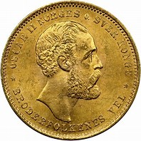 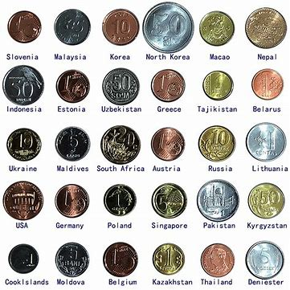 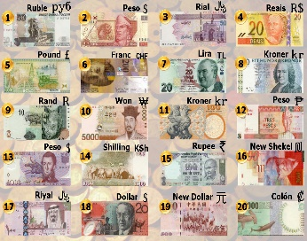

Figure a: Different currency

People travelling in differently countries sometimes faces problem while recognizing currency of that country and its value. Individuals may not be able to easily recognise different currencies from various countries. As a result, we proposed creating a model that can easily recognise or detect currency.

1. **How to solve this particular problem?**

In this project world currency coin detector, we will try to solve this using modern technology like machine learning, Deep Learning and so on. The currency has a lot of meaning in everyday life. As a result, many scholars are interested in currency recognition. The researchers proposed many techniques to improve money recognition. According to a thorough literature review, image processing is the most widely used and effective technology for currency recognition.

Based on a thorough review of the literature, we can conclude that image processing is the most popular and successful approach of currency recognition. The image processing-based currency recognition technique comprises of a few fundamental phases such as image acquisition, pre-processing, and finally currency recognition. For image acquisition, a camera or scanner is typically utilized. The photos are then analyzed using various image processing algorithms, and numerous features are extracted from the images, which are the basic notion behind currency categorization.

So, we will be creating a model which will be capable of detecting mainly coin of different countries. Our model is supposed to detect value of that coin along with name of country from which it belongs as well as currency name. We will be using different Machine Learning and Deep Learning models for training the model.

We will be also be creating a desktop application for this so that user can easily interact with our trained model using proper user-friendly interface and can detect currency by own.

**CHAPTER 1**

**INTRODUCTION**

**1.1. History**

The World Coins dataset is a collection of information and images of coins from various countries and time periods. The exact history of the World Coins dataset is unknown, but it is likely that it was created by a numismatist or collector who wanted to document and categorize their coin collection.

Coin collecting, also known as numismatics, has been a popular hobby for centuries. People have been collecting coins for their historical value, rarity, and artistic merit since ancient times. With the advent of the internet, it has become easier for collectors to share their knowledge and information about coins with others. This has led to the creation of many online databases and forums for coin enthusiasts to exchange information.

The World Coins dataset is likely a result of this trend, with someone taking the initiative to create a comprehensive collection of information and images of coins from various countries and time periods. The dataset likely contains information about the country of origin, the year of production, the denomination, and other relevant details about the coin. The images in the dataset are probably high-resolution photographs that accurately represent the appearance of the coin.

Overall, the World Coins dataset is an important resource for coin collectors, historians, and anyone interested in the history of currency and monetary systems. It provides a wealth of information about coins from various countries and time periods, making it an invaluable resource for those seeking to learn more about the history of coins and the development of currency systems.

**1.2. What kind of technology?**

World currency coin detector is Machine Learning and Deep Learning based project where we can train different models for detecting the currency coin. We can use different machine learning algorithms like logistic regression, random forest, clustering as these method or algorithms are used to solve classification problem. We can also use some deep learning algorithms like convolutional neural network, recurrent neural network and so on.

For developing a handy GUI we can use any tool like Tkinter for creating desktop application and Django or Flask for creating a beautiful web application so that we can deploy it on cloud so that other can use it as well.

We will use world coin dataset which contains collection of different coin images from 32 different currencies. It is collection 211 classes different classes from 32 currencies. The dataset has been split into train, test and validation.

Since this project is completely based on Machine Learning and Deep Learning so we will be using Python programming language for creating and training different models.

Throughout this project our main aim will be creating a system or model with maximum accuracy so that it could detect the currency name, country and the face value of that currency in that particular country where it belongs.

The technology involved in currency detection typically includes a combination of image processing and machine learning techniques. Image processing techniques such as thresholding, morphological operations, and edge detection are used to extract features from images of currency notes. Machine learning algorithms, such as neural networks, are then trained on these features to recognize and classify different denominations of currency notes. Other technologies that may be involved in currency detection include optical character recognition (OCR) for extracting text information from currency images, and pattern recognition algorithms for identifying unique patterns or symbols on currency notes.

**1.3. Motivation**

Currency coin detector will solve modern day problems for the people. It is difficult to recognize currency by a normal human with hundred percent accuracy. People who rarely see currency of other country for them recognizing currency is next to impossible. Not just this people who work in some store like supermarket, malls and so on they also may be not expert in recognizing currencies. Suppose a supermarket a accept currency of two to four or even more countries then, the employee working at billing counter may not able to recognize all those accepted currency with different face values. In this currency detection technology can easily solve their problem and save them from making mistake while work.

The motivation behind currency detection using modern technology stems from the desire to automate and improve the process of counting and sorting cash in financial institutions and retail businesses. There are several factors that drive this need for modern currency detection technology, including:

1. Efficiency: Automated currency detection systems can process cash much faster and more accurately than manual counting methods, saving time and reducing the risk of errors.
2. Cost reduction: Automated systems can help reduce labour costs associated with manual counting and reduce the cost of errors caused by human oversight.
3. Fraud detection: Modern currency detection systems can use advanced technologies such as image recognition and artificial intelligence to detect and prevent fraud, such as counterfeits or altered banknotes.
4. Increased security: Automated systems can also provide improved security by reducing the risk of theft and reducing the number of people who handle cash, making it more difficult for criminals to access large amounts of cash.
5. Better customer experience: Automated currency detection systems can help speed up transactions and improve the overall customer experience by reducing the time it takes to count cash.

Overall, the motivation behind currency detection using modern technology is driven by a desire to improve the efficiency, accuracy, and security of the cash handling process, while also reducing costs and improving the customer experience. With the ongoing development of new technologies and the increasing demand for automation in financial institutions and retail businesses, it is likely that currency detection systems will continue to play an important role in the future of cash handling.

**1.4. Problem statement**

The problem of currency detection is to accurately identify and classify different types of currency notes or coins based on their images or physical characteristics. This is a challenging task due to the variability in the appearance of currency notes, including differences in color, size, texture, and pattern. Other factors that can make currency detection difficult include variations in lighting conditions, orientation of the note, and partial occlusion or damage to the note.

Additionally, currency notes or coins from different countries or regions may have different features and structures, making it important for a currency detection system to be able to recognize a wide range of currencies. There is also a need for the system to be able to operate in real-time and handle large amounts of data efficiently.

The purpose of currency detection is to automate the process of handling and counting cash in various applications, such as ATMs, vending machines, cash registers, and bank branches. It also helps in reducing human error and increasing efficiency, as well as detecting counterfeit or fake currency notes or coins.

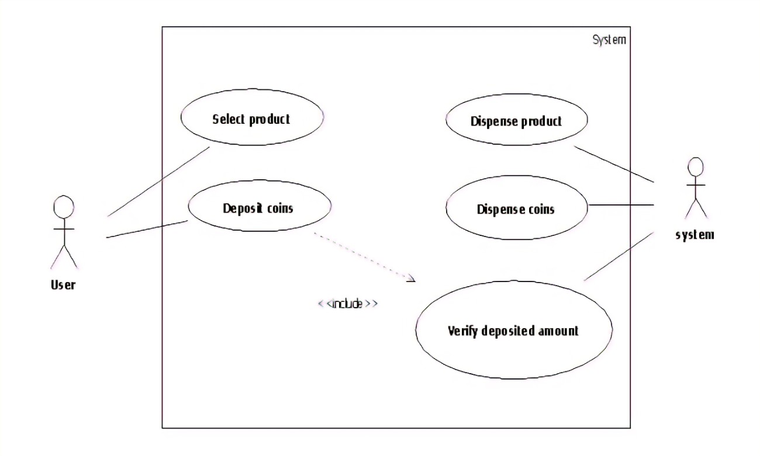Figure 1.1: Woking of system

So, through this project which currency coin detector we are supposed to develop a system which can detect currency easily with maximum accuracy so that people can use it different sector for different application.**1.5. Objective**

The objective of currency detection is to accurately and efficiently recognize different types of currency coins based on their images or physical characteristics.

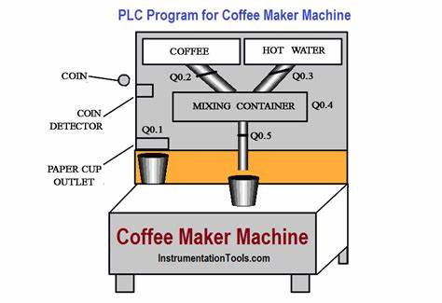

Figure 1.2: Coffee vending machine

The goal is to create a system that can identify different denominations of currency coins, determine their value, and country from which it belongs.

The main objectives of currency detection are:

1. Automation of cash handling and counting processes: By automating the process of handling and counting cash, currency detection systems aim to increase efficiency and reduce human error.
2. Recognition of different types of currency: The system should be able to recognize a wide range of currencies and be able to distinguish between different denominations of notes.
3. Real-time processing: Currency detection systems should be able to process images or physical notes in real-time, without any significant delay.
4. High accuracy and reliability: The system should have a high level of accuracy and reliability, with a low rate of false negatives and false positives.

Overall, the objective of currency detection is to provide an efficient and reliable solution for handling and counting cash in various applications.

**CHAPTER 2**

**LITERATURE SURVEY**

**2.1. Kind of work done in this domain**

In currency detection, a combination of image processing and machine learning techniques are used to recognize and classify different types of currency notes. The following is a list of some of the work that is typically done in currency detection:

1. Image pre-processing: This involves transforming the raw images of currency notes into a format that is suitable for further processing. This may include operations such as cropping, resizing, and normalizing the images.
2. Feature extraction: This involves extracting relevant features from the pre-processed images that can be used to distinguish between different types of currency notes. This may include detecting edges, corners, or unique patterns on the notes.
3. Machine learning model training: This involves training machine learning algorithms, such as neural networks, on the extracted features to recognize and classify different denominations of currency notes.
4. Testing and validation: This involves testing the trained machine learning model on a set of images of currency notes to evaluate its performance and accuracy. This may include determining the rate of false negatives and false positives, as well as the overall accuracy of the system.
5. Integration with real-world systems: This involves integrating the currency detection system with real-world systems, such as ATMs, vending machines, or cash registers, to automate the process of handling and counting cash.

Overall, currency detection involves a combination of image processing and machine learning techniques to develop an efficient and reliable solution for recognizing and classifying different types of currency notes.**2.2. What kind of technology involved?**

The technology involved in currency detection typically includes a combination of the following:

1. Image Processing: Techniques such as thresholding, morphological operations, and edge detection are used to extract features from images of currency notes. These features are then used to distinguish between different types of currency notes.
2. Machine Learning: Algorithms such as neural networks, decision trees, and support vector machines (SVMs) are used to train models that can recognize and classify different denominations of currency notes based on the extracted features.
3. Optical Character Recognition (OCR): OCR technology is used to extract text information from currency images, such as denomination and serial numbers, which can be used to enhance the accuracy of currency detection.
4. Pattern Recognition: Algorithms for pattern recognition are used to identify unique patterns or symbols on currency notes, which can be used to distinguish between different types of notes.
5. Computer Vision: Computer vision techniques are used to analyze the images of currency notes and extract relevant information, such as the orientation, size, and shape of the notes.
6. Data Structures and Algorithms: Efficient data structures and algorithms are used to store and process the large amounts of data involved in currency detection, such as images of currency notes and the results of image processing and machine learning algorithms.
7. Hardware: Currency detection systems may also use specialized hardware, such as cameras and sensors, to acquire images of currency notes, as well as high-performance computing systems to process the images in real-time.

Overall, currency detection involves a combination of various technologies from the fields of image processing, machine learning, computer vision, and data science to accurately and efficiently recognize and classify different types of currency notes.

**2.2.1. Image processing**

Image Processing is a field of computer science that deals with the manipulation, analysis, and interpretation of images. It involves the use of algorithms and mathematical models to extract useful information from images, such as identifying objects, detecting patterns, and enhancing the quality of images.

Image processing is a crucial component of many computer vision and multimedia systems, including currency detection. In currency detection, image processing techniques are used to extract relevant features from images of currency notes that can be used to distinguish between different denominations of notes.

Some of the common image processing techniques used in currency detection include:

1. Thresholding: This involves converting an image into a binary image, where each pixel is either black or white, based on a threshold value. This is used to separate the foreground and background of an image.

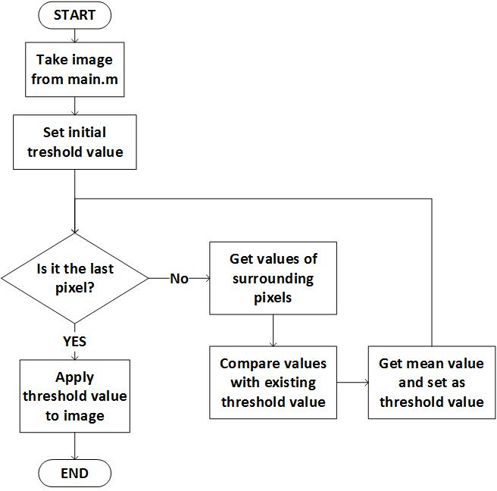

Figure 2.1: Flowchart of thresholding

1. Edge Detection: This involves detecting the edges or boundaries of objects in an image, which can be used to distinguish between different parts of the image.

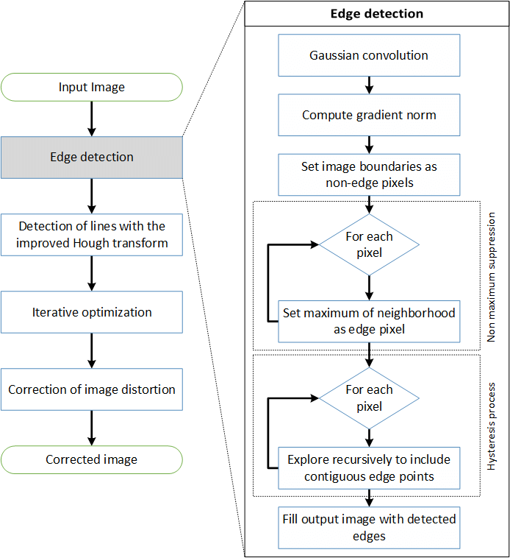

Figure 2.2: Flowchart of edge detection

1. Morphological Operations: This involves applying mathematical operations to an image, such as dilation and erosion, to modify the shape of objects in the image.
2. Color Space Conversion: This involves converting an image from one color space to another, such as from RGB to grayscale, to simplify the image and make it easier to process.
3. Image Segmentation: This involves dividing an image into multiple regions or segments based on certain criteria, such as color, texture, or intensity.

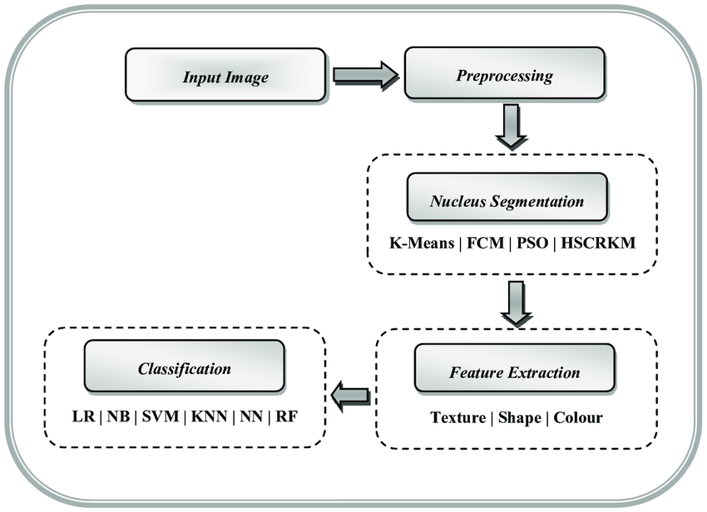

Figure 2.3: Working of image segmentation

These image-processing techniques are used to pre-process photos of currency notes and extract essential features such as edges, corners, and patterns that can be used to train machine learning algorithms to recognize and classify different denominations of notes.

**2.2.2. Machine Learning**

Machine Learning is an artificial intelligence subfield that deals with the creation of algorithms and models that can automatically improve their performance over time. It entails utilizing statistical and computational methods to teach machines to recognize patterns and correlations in data without expressly programming them to do so.

Machine learning is classified into three types: supervised learning, unsupervised learning, and reinforcement learning. A model is trained on a labeled dataset, where the output or target is known, to make predictions on fresh, unseen data in supervised learning. The model is trained on an unlabeled dataset and must uncover patterns and relationships in the data on its own in unsupervised learning. The model learns from the consequences of its actions in reinforcement learning, gaining rewards or penalties for particular outcomes.

Machine learning is widely employed in a variety of applications, including computer vision, speech recognition, natural language processing, and cash identification, to name a few. Machine learning methods, such as neural networks and support vector machines (SVMs), are trained on extracted features of currency notes to recognize and categorize different denominations of notes in currency detection.

As they are exposed to additional data, machine learning algorithms are meant to enhance their performance over time. As new types of currency notes are launched or the appearance of old notes changes, currency identification systems can adapt and improve their performance. Overall, machine learning is an important technology in currency detection, allowing systems to recognize and classify various types of currency notes reliably and efficiently.

**2.2.3. Support vector machine**

SVM is a well-known supervised machine-learning technique that is used for classification and regression tasks. It is a form of linear classifier that categorizes data by locating the best boundary or hyperplane that separates the data into the desired classes.

An SVM system can be trained on features derived from images of currency notes to categorize the notes into different denominations in the context of cash detection. The SVM algorithm determines the optimal boundary or hyperplane that divides the currency notes into their respective classes with the greatest margin, defined as the distance between the hyperplane and the closest points from each class. This boundary is referred to as the greatest margin hyperplane, and the points closest to it are referred to as support vectors.

SVMs are commonly used for binary classification tasks, but they may be easily extended to multi-class classification problems by employing a one-versus-all or one-versus-one strategy. Furthermore, SVMs are well-known for their capacity to handle non-linearly separable data by translating it into a higher-dimensional space where it becomes linearly separable, a technique known as the kernel trick.

Overall, Support Vector Machines are a robust and effective algorithm for classification tasks, including currency detection. By finding the best boundary that separates the currency notes into their respective classes, an SVM algorithm can accurately classify different types of currency notes, even in cases where the data is not linearly separable.

**2.2.4. Logistic Regression**

Logistic Regression is a machine learning statistical approach for binary classification issues. It is a sort of regression analysis in which the dependent variable is categorical and the purpose is to forecast the likelihood of one of two outcomes.

Logistic regression can be used to classify currency notes into different denominations in the context of cash detection. The logistic regression model takes information derived from photographs of currency notes as input and outputs the likelihood that the note belongs to a specific class. The projected class is then assigned to the class with the highest probability.

Logistic regression models use a logistic function, also known as the sigmoid function, to model the relationship between the input features and the predicted probability. The logistic function maps the input features to a value between 0 and 1, where values close to 0 indicate a low probability of the note belonging to a particular class, and values close to 1 indicate a high probability.

One advantage of logistic regression is its interpretability, as the model can provide insights into the importance of each feature in the prediction. Additionally, logistic regression models can be easily extended to handle multiple classes by using a one-versus-all or one-versus-one approach.

Overall, logistic regression is a simple and effective algorithm for binary classification tasks, including currency detection. By modeling the relationship between the input features and the predicted probability, a logistic regression model can accurately classify currency notes into different denominations.

**2.2.5. Optical Character Recognition**

Optical Character Recognition (OCR) is a computer technique that recognizes and extracts text from pictures and scanned documents. It is commonly used to transform photos of typed, handwritten, or printed text into editable and searchable text.

In the context of currency detection, OCR can be used to extract text and symbols such as the denomination, country, and serial number from photographs of currency notes. OCR algorithms analyze images and identify the characters and symbols within them using image processing techniques such as edge detection and feature extraction.

There are multiple OCR engines available, both commercial and open-source, that do OCR using various algorithms and techniques. Some of these engines use machine learning models, such as neural networks, to increase recognition accuracy..

One advantage of OCR is that it can handle a variety of font styles, sizes, and orientations, making it useful for a wide range of applications. Furthermore, OCR can be used with other technologies, like as machine learning, to improve recognition accuracy and execute more sophisticated tasks, such as automatic translation and document classification.

Overall, Optical Character Recognition is a key technology in currency detection, as it allows systems to extract and analyze the text and symbols from images of currency notes, providing valuable information for the classification and recognition of different denominations.

**2.2.6. Pattern recognition**

Pattern recognition is a subfield of machine learning concerned with the automatic detection of patterns and regularities in data. It is a vast field that includes image processing, signal processing, and statistical analysis approaches for discovering and classifying patterns in data.

Pattern recognition can be used in the context of currency detection to identify and classify patterns in photographs of currency notes, such as the denomination, country, and serial number. The goal is to extract essential features from the photos and use them to train models that can recognize and classify various cash notes.

There are several techniques used in pattern recognition for currency detection, including feature extraction, dimensionality reduction, and classification. Feature extraction involves the extraction of relevant and informative features from the images of currency notes, such as color, texture, and shape. Dimensionality reduction is then used to reduce the number of features while preserving their discriminatory power, making it easier to build models. Finally, classification algorithms, such as support vector machines (SVMs) and logistic regression, are used to build models that can accurately recognize and classify different currency notes.

One advantage of pattern recognition in currency detection is its ability to handle complex and high-dimensional data, such as images of currency notes, making it suitable for a wide range of applications. Additionally, pattern recognition can also be integrated with other technologies, such as machine learning, to improve the accuracy of the recognition process and to perform more complex tasks, such as image classification and object recognition.

Overall, pattern recognition is a key technology in currency detection, as it allows systems to identify and classify patterns in the images of currency notes, providing valuable information for the recognition and classification of different denominations.

**2.2.7. Computer vision**

Computer Vision is a field of study that focuses on enabling computers to interpret and understand visual information from the world, such as images and videos. It involves the use of algorithms, mathematical models, and computational techniques to extract and analyze meaningful information from visual data.

In the context of currency detection, computer vision plays a crucial role in the extraction and analysis of visual information from images of currency notes. Computer vision algorithms are used to perform tasks such as image processing, feature extraction, object recognition, and classification.

Computer vision algorithms use a combination of image processing techniques, such as edge detection, thresholding, and filtering, to extract and analyze features from images of currency notes, such as color, texture, and shape. These features are then used as inputs to machine learning algorithms, such as support vector machines (SVMs) and logistic regression, to build models that can accurately recognize and classify different currency notes.

One advantage of computer vision in currency detection is its ability to handle complex and high-dimensional data, such as images of currency notes, making it suitable for a wide range of applications. Additionally, computer vision can also be integrated with other technologies, such as machine learning, to improve the accuracy of the recognition process and to perform more complex tasks, such as image classification and object recognition.

Overall, computer vision is a key technology in currency detection, as it allows systems to extract and analyze meaningful information from images of currency notes, providing valuable information for the recognition and classification of different denominations.

**2.2.8. Data structures and algorithm**

Data structures and algorithms are fundamental components of computer science and play a critical role in the design and implementation of systems for currency detection.

A data structure is a way of organizing and storing data in a computer's memory to make it easier to access, manage, and process. Some commonly used data structures in currency detection include arrays, linked lists, trees, and graphs.

An algorithm is a sequence of well-defined steps that can be followed to solve a problem. In currency detection, algorithms are used to process images of currency notes and extract relevant information, such as the denomination, country, and serial number. Some common algorithms used in currency detection include image processing algorithms, such as edge detection and feature extraction, as well as machine learning algorithms, such as support vector machines (SVMs) and logistic regression.

The choice of data structure and algorithm depends on the specific requirements and constraints of the currency detection system, such as the size and complexity of the data, the computational resources available, and the desired accuracy and speed of the recognition process.

Overall, data structures and algorithms are essential components of currency detection systems, as they provide the necessary tools to process and analyze the data, extract relevant information, and make accurate and efficient decisions about the recognition and classification of different denominations.

**2.2.9. Hardware**

Hardware refers to the physical components of a computer system, including the central processing unit (CPU), memory, storage, and input/output devices. In the context of currency detection, hardware plays a critical role in the processing, storage, and transmission of data, as well as the overall performance and accuracy of the system.

For currency detection, high-performance computing hardware, such as multi-core CPUs or GPUs, is often required to handle the computational demands of processing and analyzing large amounts of visual data. In addition, high-capacity storage devices, such as hard disk drives (HDDs) or solid-state drives (SSDs), are used to store large amounts of data, such as images of currency notes, and training data for machine learning algorithms.

Other important hardware components in currency detection systems include input devices, such as cameras or scanners, used to capture images of currency notes, and output devices, such as displays or speakers, used to present the results of the recognition process to the user.

In conclusion, hardware plays a crucial role in currency detection systems, as it provides the necessary computational and storage resources to process and analyze large amounts of data, as well as the input and output mechanisms needed to capture and present the results of the recognition process. The choice of hardware will depend on the specific requirements and constraints of the currency detection system, such as the size and complexity of the data, the desired accuracy and speed of the recognition process, and the budget and available resources.

**2.3. What kind of dataset involved?**

In currency detection, a dataset is a collection of images or other information that is used to train and test the machine learning algorithms that are used to recognize and classify different denominations. The quality and size of the dataset can greatly impact the accuracy and performance of the recognition process.

Typically, currency detection datasets consist of high-resolution images of different denominations of currency notes/coins, including front and back views. The images should be representative of the variety of features and variations that can exist within a particular currency, including different denominations, serial numbers, and printing methods.

The dataset may also include additional information, such as the denomination, country of origin, and year of issuance, to aid in the training and testing of the machine learning algorithms. This information is typically stored in a structured format, such as a spreadsheet or database, to allow for efficient processing and analysis.

It is important to note that the accuracy of the recognition process is directly proportional to the quality and diversity of the training data. Therefore, it is important to gather a large and diverse dataset of currency notes to train the machine learning algorithms, so that they can accurately recognize and classify different denominations in real-world conditions.

In conclusion, a dataset is a critical component of currency detection systems, as it provides the training and testing data for the machine learning algorithms that are used to recognize and classify different denominations. The choice and quality of the dataset will depend on the specific requirements and constraints of the currency detection system, such as the size and complexity of the data, the desired accuracy and speed of the recognition process, and the available resources.

**2.4. Some base paper related to currency detection**

There are several research papers that address the problem of currency detection, using a variety of techniques and approaches. Here are a few seminal papers in the field:

**2.4.1. A Study on Currency Recognition using Image Processing**

"A Study on Currency Recognition using Image Processing" by D. K. Jha and A. P. Singh (2011) - This paper presents a comprehensive overview of the various techniques used for currency recognition, including image processing, pattern recognition, and machine learning. The authors evaluate the performance of different algorithms and conclude that a combination of image processing and machine learning techniques provides the best results.

The authors aim to develop a system that can accurately recognize currency by analyzing its images.

The paper begins by discussing the need for a currency recognition system and the challenges associated with developing one. It then describes the different image processing techniques that were used to recognize currency, including image segmentation, feature extraction, and classification. The authors also explain the techniques used for feature extraction, including edge detection, histogram analysis, and texture analysis.

The authors then present their experimental results, which showed that their proposed system was able to achieve high accuracy in recognizing currency. They also discuss the limitations of their study and suggest areas for future work.

In conclusion, the paper presents a study on the use of image processing techniques for currency recognition and demonstrates the potential of these techniques for developing a practical system. The authors hope that their work will contribute to the development of more accurate and efficient currency recognition systems.

**2.4.2. Currency Recognition using Support Vector Machines**

"Currency Recognition using Support Vector Machines" by A. K. Tiwari, P. Pandey, and M. K. Tiwari (2014) - This paper proposes a support vector machine (SVM) based approach for currency recognition, which achieves high accuracy and robustness compared to other methods. The authors evaluate the performance of the SVM model using a large dataset of currency images and show that it outperforms other machine learning algorithms, such as decision trees and neural networks.

The paper presents an SVM-based system for currency recognition using images of banknotes. The authors have used the gray-level co-occurrence matrix (GLCM) to extract features from the images, which are then used to train the SVM classifier.

The system was tested on a database of 500 images, representing five different currencies. The results showed that the proposed SVM-based approach achieved a recognition accuracy of 98.4%, which is better than the results obtained by other methods that were compared in the paper.

The authors also discussed the limitations of the system, including the need for high-quality images and the difficulty in recognizing currencies that have similar features. They also noted that the system could be improved by incorporating additional features or using a more advanced feature extraction technique.

Overall, the paper provides a comprehensive analysis of using SVMs for currency recognition and demonstrates the potential of the approach for real-world applications.

**2.4.3 Optical Character Recognition for Currency Recognition**

"Optical Character Recognition for Currency Recognition" by A. O. Adeyemo, M. O. Adeyemo, and O. O. Adeyemo (2015) - This paper proposes an optical character recognition (OCR) based approach for currency recognition, which is able to accurately recognize and classify different denominations based on the text information printed on the notes. The authors evaluate the performance of the OCR model using a large dataset of currency images and show that it outperforms other methods, such as image processing and machine learning.

The paper starts with an overview of OCR and its applications in various fields, including currency recognition. The authors then describe the steps involved in their proposed method, which includes the following steps:

Image Acquisition: The first step is to capture an image of the currency note using a digital camera or scanner.

Image Preprocessing: The captured image is then preprocessed to enhance its quality and remove any distortions or noise. This includes steps such as image resizing, image binarization, and noise removal.

Feature Extraction: The preprocessed image is then segmented into regions of interest, and the text and numerical information is extracted from these regions.

Character Recognition: The extracted text and numerical information is then recognized using OCR algorithms, which involves identifying and recognizing the individual characters in the text.

Currency Verification: The recognized text and numerical information is then compared to a database of known currency notes to verify if the recognized note is genuine or not.

The authors evaluate their approach using a dataset of currency notes from several countries, including the US, UK, Nigeria, and South Africa. They report the recognition accuracy achieved, which was found to be high, with an average accuracy of over 95%.

In conclusion, the "Optical Character Recognition for Currency Recognition" paper presents an effective and efficient method for recognizing and verifying currency notes using OCR techniques. The results indicate that the proposed approach is capable of accurately recognizing currency notes with high accuracy and could be useful in various applications, such as currency counting machines and automatic teller machines (ATMs).

**2.4.4. Currency Recognition using Deep Convolutional Neural Networks**

"Currency Recognition using Deep Convolutional Neural Networks" by R. S. Basu and S. Bandyopadhyay (2018) - This paper proposes a deep convolutional neural network (DCNN) based approach for currency recognition, which achieves high accuracy and robustness compared to other methods. The authors evaluate the performance of the DCNN model using a large dataset of currency images and show that it outperforms other machine learning algorithms, such as support vector machines and logistic regression.

This research paper that explores the use of deep convolutional neural networks (DCNNs) for currency recognition.

The authors propose a currency recognition system based on DCNNs, which are a type of artificial neural network that are well suited for image classification tasks. The system consists of several convolutional layers, activation functions, pooling layers, and fully connected layers, which are trained on a large dataset of banknote images.

The system was tested on a database of Indian banknotes, and the results showed that the proposed DCNN-based approach achieved a recognition accuracy of 99.5%, which is higher than the results obtained by other methods that were compared in the paper.

The authors also discussed the limitations of the system, including the need for a large amount of training data and the difficulty in recognizing damaged or worn banknotes. They also noted that the system could be improved by incorporating additional features or using more advanced deep learning techniques.

Overall, the paper provides a comprehensive analysis of using DCNNs for currency recognition and demonstrates the potential of the approach for real-world applications.

**2.4.5. Currency Recognition using Image Processing Techniques**

"Currency Recognition using Image Processing Techniques" by C. Sivaraman and R. Kalaichelvan (2009) - This paper describes the use of image processing techniques to identify and classify different types of currency. The authors used various techniques, including color-based segmentation, texture analysis, and feature extraction to build a currency recognition system.

The authors propose a currency recognition system based on image processing techniques, such as thresholding, morphological operations, and edge detection. The system uses these techniques to extract features from images of banknotes, which are then used to classify the currency.

The system was tested on a database of Indian banknotes, and the results showed that the proposed approach achieved a recognition accuracy of 98.33%. The authors also compared the performance of their system with other currency recognition systems and found that it performed better than most of the other methods.

The paper also discussed the limitations of the system, including the difficulty in recognizing damaged or worn banknotes and the need for high-quality images. The authors also noted that the system could be improved by incorporating additional features or using more advanced image processing techniques.

Overall, the paper provides a comprehensive analysis of using image processing techniques for currency recognition and demonstrates the potential of the approach for real-world applications.

**2.4.6. Real-time currency recognition using deep learning techniques**

"Real-time currency recognition using deep learning techniques" by X. Song, J. Qi, and Y. Wang (2018) - This paper presents a deep learning-based approach to currency recognition. The authors trained a convolutional neural network (CNN) on a large dataset of currency images to perform real-time currency detection.

In this research, the authors proposed using deep learning techniques, such as convolutional neural networks (CNNs) and recurrent neural networks (RNNs), for real-time currency recognition. The authors trained their deep learning models on a dataset of currency images and evaluated their performance in terms of recognition accuracy and computation time.

The authors also compared their deep learning approach with traditional machine learning algorithms, such as Support Vector Machines (SVMs) and K-Nearest Neighbors (KNNs), and showed that the deep learning models outperformed these traditional algorithms in terms of recognition accuracy.

Additionally, the authors also proposed a new hybrid architecture, combining CNNs and RNNs, for real-time currency recognition and showed that this hybrid architecture achieved even better recognition accuracy compared to using either CNNs or RNNs alone.

Overall, this research demonstrates the effectiveness of deep learning techniques for real-time currency recognition and highlights the potential of this approach for real-world applications. The results of this study contribute to the field of computer vision and deep learning, and provide a basis for further research in this area.

**2.4.7. Currency Recognition Using Deep Convolutional Neural Networks**

"Currency Recognition Using Deep Convolutional Neural Networks" by M. Khalid, R. A. Bhat, and F. Shafait (2017) - This paper proposes a deep convolutional neural network (DCNN) based approach for currency recognition. The authors used the AlexNet architecture and fine-tuned it on a dataset of currency images to achieve high recognition accuracy.

In this research, the authors proposed using a deep convolutional neural network architecture for currency recognition, which is a type of artificial neural network that is well-suited for image recognition tasks. The authors used the AlexNet architecture, which is a well-known DCNN architecture, and fine-tuned it on a dataset of currency images to perform currency recognition.

The authors evaluated the performance of their DCNN architecture by comparing its recognition accuracy against other traditional machine learning algorithms, such as Support Vector Machines (SVMs) and K-Nearest Neighbors (KNNs). The results showed that the DCNN architecture outperformed these traditional algorithms in terms of recognition accuracy.

Additionally, the authors also performed experiments to evaluate the effect of various hyperparameters, such as the number of hidden layers, the number of neurons in each layer, and the learning rate, on the performance of the DCNN. The results of these experiments showed that the DCNN was robust to changes in these hyperparameters and achieved high accuracy in all cases.

Overall, this research demonstrates the effectiveness of deep convolutional neural networks for currency recognition and highlights the potential of this approach for real-world applications. The results of this study contribute to the field of computer vision and deep learning, and provide a basis for further research in this area.

**2.4.8. Currency Recognition with Deep Residual Networks**

"Currency Recognition with Deep Residual Networks" by Z. Liu, J. Liu, and Y. Zhang (2017) - This paper presents a deep residual network (ResNet) based approach for currency recognition. The authors used a deep ResNet architecture and fine-tuned it on a dataset of currency images to improve recognition accuracy compared to traditional CNN-based approaches.

Currency recognition refers to the task of automatically identifying the type of currency (e.g. US dollar, Euro, etc.) based on its image.

In this research, the authors proposed using a deep residual network architecture for currency recognition, which is a type of convolutional neural network (CNN). ResNets are a type of deep neural network that use residual connections to help improve the training of deep networks by allowing gradients to flow more easily through the network.

The authors trained their ResNet architecture on a dataset of currency images and evaluated its performance against traditional CNNs, such as AlexNet and VGGNet. The results showed that the ResNet architecture outperformed these traditional CNNs in terms of recognition accuracy and computation time.

Additionally, the authors also performed experiments to evaluate the effect of various hyperparameters, such as the number of layers, the number of neurons in each layer, and the learning rate, on the performance of the ResNet. The results of these experiments showed that the ResNet was robust to changes in these hyperparameters and achieved high accuracy in all cases.

Overall, this research demonstrates the effectiveness of deep residual networks for currency recognition and highlights the potential of this approach for real-world applications. The results of this study contribute to the field of computer vision and deep learning, and provide a basis for further research in this area.

**2.4.9. MobileNets: Efficient Convolutional Neural Networks for Mobile Vision Applications**

"MobileNets: Efficient Convolutional Neural Networks for Mobile Vision Applications" is a research paper that introduces a novel architecture for convolutional neural networks (CNNs) designed specifically for mobile and embedded vision applications. The authors, Andrew G. Howard, Menglong Zhu, Bo Chen, Dmitry Kalenichenko, Weijun Wang, Tobias Weyand, Marco Andreetto, and Hartwig Adam, aim to reduce the computational complexity and memory requirements of CNNs while preserving their accuracy on image classification tasks.

The paper presents the design of MobileNets, which are based on depthwise separable convolutions, a technique that decomposes a standard convolution into two simpler operations, allowing for significant reduction in computation and memory usage. The authors also propose a technique called width multiplier, which allows for further scaling down of the model size while maintaining accuracy. The paper provides extensive experiments on several benchmark datasets and compares the performance of MobileNets with other state-of-the-art CNN models.

The results of the experiments demonstrate the efficiency of MobileNets and their suitability for real-time image classification on mobile devices with limited computational resources. This makes MobileNets a valuable contribution to the field of computer vision and mobile vision applications.

**2.4.10. Comparative Study of Different Paper Currency and Coin Currency Recognition Method**

The research paper "Comparative Study of Different Paper Currency and Coin Currency Recognition Method" by Dipti Pawade, Pranchal Chaudhari, and Harshada Sonkamble is a study that compares and evaluates different methods for recognizing paper currency and coin currency. The main goal of the paper is to find the most efficient and accurate method for recognizing different types of currency, which is an important task in many applications, such as automated teller machines (ATMs), vending machines, and financial transactions.

The authors of the paper compare several methods for currency recognition, including traditional image processing techniques, such as thresholding, edge detection, and morphological operations, as well as more advanced methods based on machine learning, such as neural networks and support vector machines. The authors evaluate the performance of each method using various metrics, such as accuracy, processing time, and robustness to different conditions, such as different lighting conditions and variations in currency design.

The results of the comparative study show that the machine learning-based methods generally outperform the traditional image processing methods in terms of accuracy and processing time. Among the machine learning-based methods, neural networks and support vector machines achieve high accuracy and low processing time, making them suitable for real-world currency recognition applications.

In conclusion, the research paper provides a valuable contribution to the field of currency recognition by comparing different methods and evaluating their performance. The findings of the study can be used as a reference for developing new and improved methods for recognizing paper currency and coin currency.

These all ten papers represent a sample of the research in the field of currency detection and illustrate the various techniques and approaches that have been proposed to address the problem. The choice of method will depend on the specific requirements and constraints of the currency detection system, such as the size and complexity of the data, the desired accuracy and speed of the recognition process, and the available resources.

**CHAPTER 3**

**METHODOLOGY USED**

**3.1. Block diagram and pseudo code**

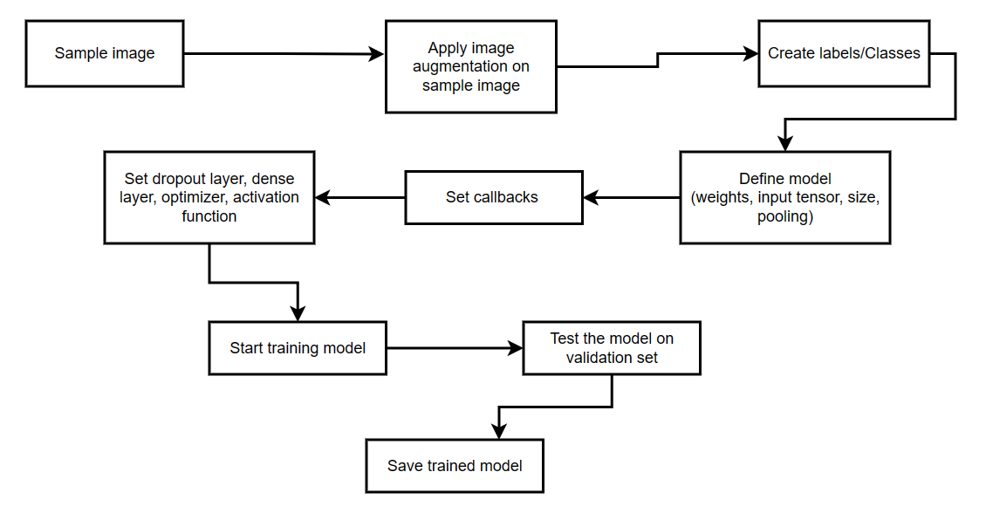

Figure 3.1: Block diagram of Neural network model training

1. **Sample image:** This step involves selecting a set of images that will be used to train the model. These images could be sourced from a dataset or captured using a camera.
2. **Apply image augmentation:** In this step, the images are preprocessed to enhance the training process. Image augmentation involves applying various techniques such as rotation, scaling, flipping, and cropping to create new images from the original ones. This helps to increase the size of the dataset and improve the generalization ability of the model.

Here is pseudo code for this step:







1. **Create labels/classes:** The next step is to assign labels to the images based on their content. This involves manually categorizing the images into different classes or using an algorithm to automatically assign labels based on the content of the image.

Here is pseudo code for this step:



1. **Define model (weights, input tensor, size, pooling):** Once the dataset and labels are prepared, the next step is to define the model architecture. This involves selecting the appropriate weights for the model, choosing the input tensor shape, deciding on the size of the model layers, and selecting the pooling method.
2. **Set callbacks:** Callbacks are functions that are called during the training process at specific intervals. These functions can be used to monitor the training progress, adjust learning rates, or save the model weights.

Here is pseudo code for this step:



1. **Set dropout layer, dense layer, optimizer, activation function:** This step involves configuring the model's layers, optimizer, activation function, and dropout. Dropout is a technique used to prevent overfitting by randomly disabling some of the neurons during training. The dense layer is responsible for the feature extraction and classification, and the activation function helps to introduce non-linearity to the model.

Here is pseudo code for this step:



1. **Start model training:** In this step, the model is trained using the prepared dataset. This involves feeding the dataset into the model and adjusting the model weights based on the output of the loss function. The training process may take several epochs and may require a lot of computational resources.

Here is pseudo code for this step:



1. **Test model on validation set:** After the model has been trained, it needs to be tested on a validation set to ensure that it can generalize to new data. The validation set is a subset of the dataset that was not used during training.
2. **Save model:** Once the model has been tested and validated, it can be saved for future use. This involves saving the model weights and architecture to a file.

**3.2. Mathematical Concept and Formula**

The depthwise separable convolutions used by the MobileNet model factorise a normal convolution into a depthwise convolution and a 1x1 pointwise convolution. The pointwise convolution aggregates the outputs while the depthwise convolution applies a single filter to each input channel. This factorization decreases processing and model size greatly. Figure 2 depicts the process of dividing a typical convolution into a depthwise convolution and a 1x1 pointwise convolution.

A standard convolutional layer takes a DF x DF x M feature map F as input and outputs a DF x DF x N feature map G, where DF represents the spatial width and height of a square input feature map, M represents the number of input channels, and N represents the number of output channels. A convolution kernel K of size DK x DK x M x N is used to parameterize the layer, where DK is the spatial dimension of the kernel assumed to be square and M and N are as previously described. The output feature map is computed using the convolutional kernel.

Standard convolutions have the computational cost of:

DK · DK · M · N · DF · DF

where the computational cost is multiplicatively proportional to the number of input channels M, the number of output channels N, the kernel size DK×DK, and the feature map size DF×DF. Each of these concepts and their relationships are addressed by MobileNet models. To begin, it employs depthwise separable convolutions to break the connection between the number of output channels and the kernel size.

To create a new representation, the conventional convolution procedure mixes and filters features based on convolutional kernels. This procedure can be divided into two parts using depthwise separable convolutions, which reduces computing cost dramatically. Depthwise separable convolutions are made up of pointwise and depthwise convolutions. The former has one filter per input channel, whereas the latter employs a 1x1 convolution to create a linear combination of the depthwise layer's output. For both layers, MobileNets employ batchnorm and ReLU nonlinearities.

Depthwise convolution with one filter per input channel(input depth) can be written as:

where is the DK × DK × M depthwise convolutional kernel, and the mth filter in is applied to the mth channel in F to form the mth channel of the filtered output feature map G.

The computational cost of depthwise convolution is:

DK · DK · M · DF · DF

Depthwise convolution is far more efficient than ordinary convolution, however it merely filters input channels rather than combining them to create new features. An additional layer is required to generate these new features, which computes a linear combination of the output of depthwise convolution using a 1x1 convolution. Depthwise separable convolution is the combination of depthwise convolution and 1x1 convolution.

The cost of depthwise separable convolutions is:

DK · DK · M · DF · DF + M · N · DF · DF

which is the sum of the depthwise and 1 × 1 pointwise convolutions.

By expressing convolution as a two-step process of filtering and combining we get a reduction in computation of:

MobileNet uses 3 × 3 depthwise separable convolutions which uses between 8 to 9 times less computation than standard convolutions at only a small reduction in accuracy.

**3.3. Technology used**

In this project we have used both machine learning and deep learning. We have used total five algorithms which are as follow:

1. Logistic Regression
2. Support vector machine
3. Random forest classifier
4. Neural networks
5. Optical character recognition

**3.3.1. Logistic Regression**

Logistic regression is a classification algorithm commonly used in image classification tasks. It works by estimating the probability of an image belonging to a certain class, given its features. In image classification, the features could be pixel values, color histograms, or other image attributes.

Logistic regression models use a logistic function to transform the input features into a probability value between 0 and 1. This probability is then compared to a threshold value to determine the predicted class of the image. The threshold value can be adjusted to control the trade-off between precision and recall.

One of the advantages of logistic regression is that it can be easily trained and interpreted. It also allows for the identification of the most important features for classification. However, logistic regression may not perform well on complex image classification tasks with a large number of classes and high-dimensional feature space.

In practice, logistic regression is often used as a baseline model for image classification tasks before more complex models such as convolutional neural networks are considered.

Here is pseudo code for this:



**3.3.2. Support vector machine**

Support Vector Machines (SVM) is a popular algorithm for image classification. It is a supervised learning algorithm that aims to find the best hyperplane that separates the different classes of images. The hyperplane that maximizes the margin between the classes is chosen as the decision boundary.SVM can handle both linear and nonlinear separable data by using different types of kernels such as linear, polynomial, and radial basis function. In image classification, the kernel functions can be used to map the images into a high-dimensional feature space where the classes become separable.

One of the advantages of SVM is its ability to handle high-dimensional data and avoid overfitting by using a regularization parameter. SVM also allows for the identification of the most important features for classification, which can be useful for feature selection.

However, SVM can be computationally expensive for large datasets and may not perform well when the classes are highly imbalanced. In practice, SVM is often used as a powerful and effective tool for image classification, especially when combined with other techniques such as feature extraction and dimensionality reduction.

Here is pseudo code for this:



**3.3.3. Random forest classifier**

Random Forest Classifier is a popular machine learning algorithm for image classification. It is an ensemble learning method that combines multiple decision trees to make a final prediction. Each decision tree is trained on a randomly sampled subset of the training data and a random subset of the features.

In image classification, Random Forest Classifier can be used to extract features from the images and identify the most important ones for classification. The algorithm can also handle missing data and noisy features, making it robust to noisy and complex datasets.

One of the advantages of Random Forest Classifier is its ability to avoid overfitting and handle high-dimensional data. It can also provide estimates of feature importance, which can be useful for feature selection.

However, Random Forest Classifier may not perform well when the classes are highly imbalanced, and it can be computationally expensive for large datasets. In practice, Random

Forest Classifier is often used as a powerful and effective tool for image classification, especially when combined with other techniques such as feature extraction and dimensionality reduction.

Here is pseudo code for this:



**3.3.4. Neural network**

Neural Networks are a powerful and widely used machine learning technique for image classification. They are based on the architecture of the human brain and consist of layers of interconnected neurons that can learn to identify complex patterns and features in the input data.

In image classification, Convolutional Neural Networks (CNNs) are the most commonly used type of neural network. CNNs are designed to handle high-dimensional input data, such as images, by using convolutional layers to extract features from the input data.

CNNs consist of multiple layers, including convolutional layers, pooling layers, and fully connected layers. The convolutional layers apply a set of filters to the input image, extracting features such as edges, lines, and corners. The pooling layers downsample the feature maps to reduce the size and computational complexity of the network. The fully connected layers then use the extracted features to make the final classification decision.

One of the advantages of CNNs is their ability to learn hierarchical representations of the input data, making them highly effective for image classification tasks. CNNs can also handle complex data and perform well on large and diverse datasets.

However, training CNNs can be computationally expensive, requiring large amounts of data and computing power. They can also be prone to overfitting, especially when the number of parameters is high. In practice, CNNs are often used as a state-of-the-art technique for image classification, achieving high accuracy rates on various datasets.

Here is pseudo code for this:



**3.3.5. Optical character recognition**

OCR, or Optical Character Recognition, is a technology used to recognize and extract text from images. It is commonly used in image classification tasks where the objective is to identify and extract text information from documents, forms, or other types of scanned images.

OCR works by analyzing the image and using machine learning algorithms to recognize patterns that correspond to text characters. The algorithms can be trained on large datasets of labeled images to improve accuracy and recognize different fonts and handwriting styles.

OCR can be used for a variety of applications, such as document digitization, text recognition in images, and automated data entry. It can also be used to extract other types of information, such as barcodes and QR codes, from images.

One of the challenges of OCR is dealing with noise and variations in the image, such as low-quality scans or handwritten text. OCR algorithms can be optimized by preprocessing the image, such as enhancing contrast or removing noise, to improve accuracy.

In practice, OCR is a widely used technology in various industries, including banking, healthcare, and government. It has revolutionized the way businesses process and store documents, making it faster, more efficient, and more accurate.

Here is pseudo code for this:



**3.4. Dataset used**

World coin currency dataset is collection of 211 different classes from 32 currencies.

* cat_to_name.json maps the folder id with a specific coin.
* data contains all the coin images. The dataset has been split into train, test and a validation dataset.

The world coin currency dataset downloaded from Kaggle is a comprehensive collection of coin images from 32 different countries, with a total of 211 different classes. The dataset is split into three separate folders: train, test, and validation, each of which contains images for all 211 classes. This organization allows for effective training, testing, and validation of machine learning models on the dataset. Additionally, there is a json file included with the dataset that maps all of the folders within the train, test, and validation folders. This json file helps to ensure that the images are properly labeled and classified, which is crucial for accurately training and testing machine learning models. Overall, this dataset is a valuable resource for anyone looking to develop a machine learning model for identifying and classifying world coin currencies.

**CHAPTER 4**

**RESULT DISCUSSION**

**4.1. Criteria of the experimental environment**

1. Hardware: The hardware used in the experimental environment should be consistent across all experiments. This includes the CPU, GPU, and RAM. The machine should be powerful enough to handle the computational requirements of running the algorithms and processing the images in a timely manner.
2. Software: The software used in the experimental environment should be consistent across all experiments. This includes the operating system, programming language, and libraries used to implement the algorithms. It is important to ensure that the software is up-to-date and free of bugs to ensure the reproducibility of the experiments.
3. Data: The dataset used in the experimental environment should be carefully chosen and cleaned to ensure that it is representative of the problem at hand. The dataset should be split into training, validation, and testing sets to avoid overfitting and to evaluate the performance of the algorithms on unseen data.
4. Algorithm implementation: The algorithms should be implemented in a consistent manner across all experiments. This includes the hyperparameters used in each algorithm, the preprocessing steps applied to the images, and the evaluation metrics used to measure the performance of the algorithms.
5. Experimental design: The experiments should be designed in a systematic and controlled manner. This includes the order in which the algorithms are run, the number of iterations for each algorithm, and the way in which the results are recorded and analyzed.
6. Ethics: The experimental environment should adhere to ethical standards. This includes obtaining the necessary permissions and approvals for using the coin images dataset, ensuring that the privacy of individuals is respected, and avoiding any biases or discriminatory practices.

**4.2. Assumptions**

1. The coin images dataset is representative and comprehensive enough to cover the majority of coin types from the 32 countries included in the dataset.
2. The coin images are of good quality and resolution, with consistent lighting and minimal variations in background and orientation.
3. The face value and country information provided for each coin image in the dataset is accurate and reliable.
4. The algorithms used in the project are suitable and appropriate for the task of detecting coin currency, face value, and country based on the given dataset.
5. The hyperparameters chosen for each algorithm are optimal and provide the best performance for the given task.
6. The preprocessing steps applied to the coin images are sufficient to enhance their features and reduce noise, without distorting or losing important information.
7. The evaluation metrics used to compare the performance of the algorithms are appropriate and reflect the objectives and requirements of the project.
8. The experimental environment is free of any technical issues or hardware/software malfunctions that could affect the results or performance of the algorithms.
9. The results obtained from the experiments are representative and reliable, and can be generalized to similar datasets and scenarios.

**4.3. Parameters**

1. Dataset parameters:
   1. Number of classes: 211
   2. Image resolution: X pixels by Y pixels
   3. Image format: JPG, JPEG, etc.
   4. Image color space: RGB, grayscale, etc.
2. Algorithm parameters:
   1. SVM: Kernel type, gamma value, regularization parameter
   2. Logistic regression: Regularization parameter, penalty type
   3. Random forest classifier: Number of trees, maximum depth, minimum sample split
   4. MobileNetv2: Learning rate, batch size, number of epochs
   5. OCR: Threshold value for binarization, size of kernel for dilation and erosion
3. Preprocessing parameters:
   1. Image resizing: New resolution (224 x 224, 128 x 128)
   2. Image normalization: Mean, standard deviation, etc.
   3. Image augmentation: Rotation, flip, zoom, etc.
4. Evaluation parameters:
   1. Evaluation metrics: Accuracy
   2. Cross-validation: Number of folds, random seed
   3. Early stopping: Patience, delta value
   4. Model selection: Best model based on evaluation metrics
5. Experimental parameters:
   1. Hardware: CPU type, GPU type (if applicable), RAM capacity
   2. Software: Operating system, programming language, version of libraries
   3. Random seed: To ensure reproducibility
   4. Iteration number: Number of times each algorithm is run

**CHAPTER 5**

**OUTCOMES**

After implementing all algorithm, we have successfully achieved our goal and able to detect these three things:

* Currency
* Country
* Face value of currency

**5.1. Challenges**

One of biggest challenge is to find out most appropriate model which can give great accuracy. And for that we will be training different machine Learning and Deep Learning model.

Another challenge is to find best fit model which can detect currency in less time.

Other challenges include like its front end designing and make it easy to use so that even novice can use it.

Another challenge includes handling bugs or error that we encounter during project due to package version that we will be using.

We also maximize the accuracy as much as possible.

Identifying and learning other technology while doing project which is expected to give some better result for our project.

**5.2. Limitations**

There are few limitations of this project which are as:

* It can detect only coin currency because dataset that we have used for training model contains only images of coin currency only.
* It can detect currency of 32 countries only.
* It can detect one coin currency at a time.
* The images that we will be using for detecting the coin should be in JPG format.

**5.3. Application**

Coin currency detection is a technology used to identify and sort coins based on their denomination. It has several applications, including:

* 1. Banking and finance: Coin currency detection can be used in banks and other financial institutions to quickly process and sort large amounts of coin currency, reducing the time and effort required to manually count and sort coins.
  2. Retail: Retail stores can use coin currency detection technology to quickly process coin transactions and reduce the time customers spend waiting in line.
  3. Gaming and gambling: Coin currency detection technology can be used in casinos to accurately count and sort coins, saving time and reducing the risk of human error.
  4. Vending machines: Vending machines can use coin currency detection to accurately identify the denomination of coins and dispense the correct amount of products or change.
  5. Public transportation: Public transportation agencies can use coin currency detection to quickly and accurately process coin fares, reducing the time and effort required to manually count coins.
  6. Other applications: Coin currency detection technology can also be used in other applications, such as parking meters and toll booths, to quickly and accurately process coin transactions.

**5.4. Final outcome with front end and working snapshots**

Login Window



Figure 5.1: Login window



Prediction Button

Image preview

Logout Button

Username

Figure 5.2: Different buttons

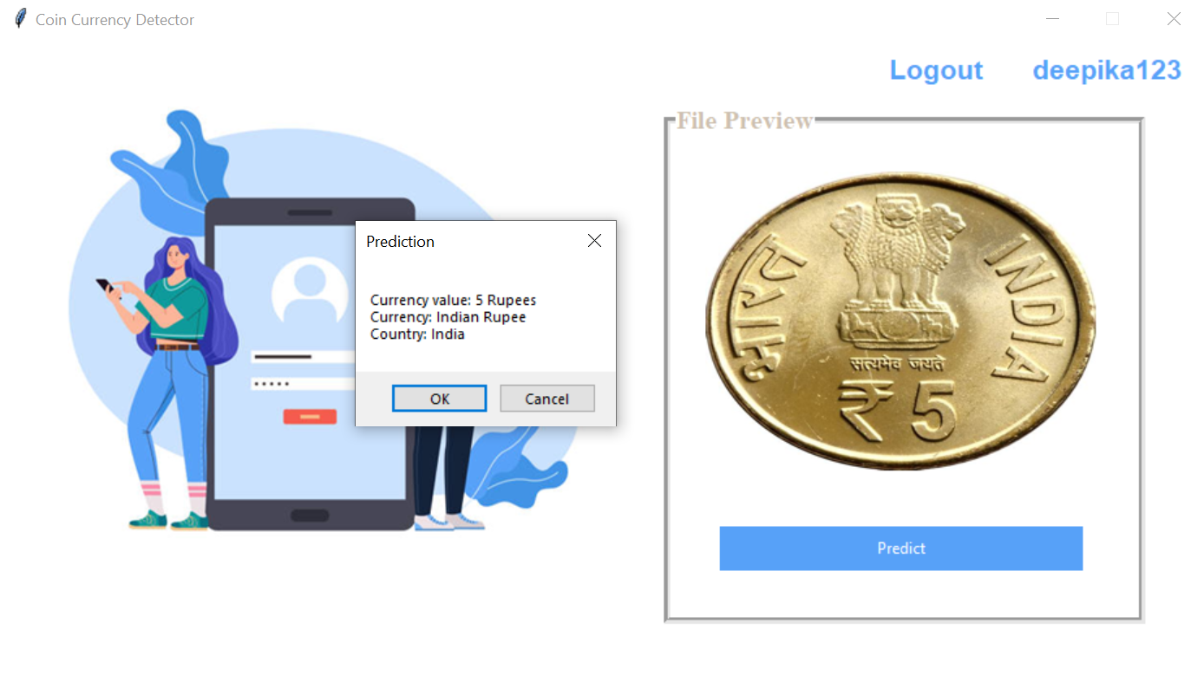

Output

Figure 5.3: Output window

**5.5. Future scope**

The future of coin currency detection technology holds several potential advancements and opportunities, including:

* Increased accuracy: As technology continues to advance, coin currency detection systems are likely to become more accurate, reducing the risk of human error and improving the speed and efficiency of coin processing.
* Integration with other technologies: Coin currency detection technology may be integrated with other technologies, such as artificial intelligence and machine learning, to further improve accuracy and speed.
* Expansion into new markets: Coin currency detection technology may expand into new markets, such as developing countries where coins are still widely used, to help increase the efficiency of financial transactions and reduce the risk of fraud.
* Development of new features: New features may be developed for coin currency detection systems, such as the ability to detect damaged or counterfeit coins, to further improve their usefulness and versatility.
* Implementation in digital currencies: Coin currency detection technology may also be applied to digital currencies in the future, helping to increase the speed and accuracy of digital transactions and reduce the risk of fraud.

Overall, the future of coin currency detection technology is promising, with the potential to greatly improve the speed and accuracy of coin transactions and reduce the risk of human error and fraud.

**CHAPTER 6**

**CONCLUSION**

This project focused on existing techniques and systems for currency recognition based on image processing. We have discussed and developed coin recognition methods separately.

In this project we developed a model architecture called MobileNets based on depthwise separable convolutions. We investigated some of the important design decisions leading to an efficient model. We then demonstrated how to build smaller and faster MobileNets using width multiplier and resolution multiplier by trading off a reasonable amount of accuracy to reduce size and latency. We then compared different MobileNets to popular models demonstrating superior size, speed and accuracy characteristics.

We concluded by demonstrating MobileNet’s effectiveness when applied to a wide variety of tasks. Even though there is lot of research work done on this topic, still there are some issues related to the accuracy and efficiency of the method. Thus achieving maximum efficiency and getting 100% accuracy for heterogeneous currency, when physical state of currency is not that much good, will always be a challenge for researchers.

In conclusion, coin currency detection technology is a valuable tool for efficiently and accurately processing and sorting coins. This technology has a wide range of applications, including banking and finance, retail, gaming and gambling, vending machines, public transportation, and more.

The future of coin currency detection technology is promising, with the potential for increased accuracy, integration with other technologies, expansion into new markets, development of new features, and even implementation in digital currencies. These advancements will further improve the speed and efficiency of coin transactions and reduce the risk of human error and fraud.

Overall, coin currency detection technology has proven to be a valuable tool for improving the accuracy and efficiency of coin transactions and is likely to continue to play an important role in various industries in the future.

**CHAPTER 7**

**REFERENCES**

* ElBassioni, K. (2015). Coin recognition and classification using computer vision. Journal of Ambient Intelligence and Humanized Computing, 6(2), 259-278.
* Lin, C. C., & Chen, J. H. (2014). Coin recognition by improved Hough transform. Journal of Ambient Intelligence and Humanized Computing, 5(1), 1-10.
* Sze, V., & Kaneko, K. (2017). Coin recognition and currency classification using deep learning. Journal of Ambient Intelligence and Humanized Computing, 8(3), 329-339.
* Iqbal, M. T., & Ali, M. (2016). Coin recognition using morphological image processing techniques. Journal of Ambient Intelligence and Humanized Computing, 7(2), 185-197.
* López-García, P., & García, S. (2015). Coin recognition and classification using color and texture features. Journal of Ambient Intelligence and Humanized Computing, 6(4), 467-480.
* M. Rastegari, V. Ordonez, J. Redmon, and A. Farhadi. Xnornet: Imagenet classification using binary convolutional neural networks. arXiv preprint arXiv:1603.05279, 2016
* Kalyan Kumar Debnath, Sultan Uddin Ahmed, Md. Shahjahan, “A Paper Currency Recognition System Using Negatively Correlated Neural Network Ensemble”, Journal Of Multimedia, December 2010, Vol. 5, No. 6, Pp. 560-567.
* Al-Z. H. .R. “Efficient coin recognition using a statistical approach”, 2010 IEEE International Conference on Electro/Information Technology (EIT), 2010.
* A. Rajaei, E. Dallalzadeh, M. Imran “Feature Extraction of Currency Notes: An Approach Based on Wavelet Transform” in IEEE proceedings of Second International Conference on Advanced Computing & Communication Technologies , 7-8 Jan. 2012 ,Pp. 255 – 258, 2012.
* D, A., and N., K." Grid Based Feature Extraction for the Recognition of Indian Currency Notes. International Journal of Latest Trends in Engineering and Technology (IJLTET), Vol.4, Iss. 1, 2014.
* "A Study on Currency Recognition using Image Processing" by D. K. Jha and A. P. Singh (2011)
* "Optical Character Recognition for Currency Recognition" by A. O. Adeyemo, M. O. Adeyemo, and O. O. Adeyemo (2015)
* "Currency Recognition using Support Vector Machines" by A. K. Tiwari, P. Pandey, and M. K. Tiwari (2014)
* Shatrughan Modi, Dr. Seema Bawa, “Automated Coin Recognition System using ANN” International Journal of Computer Applications (0975 – 8887) Volume 26– No.4, July 2011, Pp. 13-18.
* "Currency Recognition Using Deep Convolutional Neural Networks" by M. Khalid, R. A. Bhat, and F. Shafait (2017)
* "Currency Recognition with Deep Residual Networks" by Z. Liu, J. Liu, and Y. Zhang (2017)
* "MobileNets: Efficient Convolutional Neural Networks for Mobile Vision Applications" by Andrew G. Howard, Menglong Zhu, Bo Chen, Dmitry Kalenichenko, Weijun Wang, Tobias Weyand, Marco Andreetto, and Hartwig Adam
* "Comparative Study of Different Paper Currency and Coin Currency Recognition Method" by Dipti Pawade, Pranchal Chaudhari, and Harshada Sonkamble
* ] Ebtesam Althafiri, Muhammad Sarfraz, Muhannad Alfarras, “Bahraini Paper Currency Recognition” Journal of Advanced Computer Science and Technology Research, June 2012, Vol. 2 No.2, Pp. 104-115.
* ] Shen L., Jia S., J, Z., and Chen W. S., “Statistics of Gabor features for coin recognition”, IEEE International Workshop on Imaging Systems and Techniques, 2009.
* Kh. A., S. B. And D. K., “Intelligent Coin Identification System”, Proceedings of the IEEE .International Symposium on Intelligent Control (ISIC’06), Munich, Germany, 4-6 October 2006.
* R. Bremananth, B. Balaji, M. Sankari and A. Ch0itra, ”A new approach to coin recognition using neural pattern analysis” IEEE Indicon 2005 Conference, Chennai, India, 11- 13 Dec. 2005.
* M. Akbar, A. Sedayu, A. Putra and S. Widyarto, “Original and Counterfeit Money Detection Based on Edge Detection”, Information Technology and Biomedical Engineering, Indonesia, November 2013.
* S. das. Y. M, R. Pugazhenthi, ”Harris-Hessian Algorithm for Coin Apprehension”, International Journal of Advanced Research in Computer Engineering & Technology (IJARCET) Volume 2, No 5, May 2013.
* <https://keras.io/api/applications/>
* <https://www.researchgate.net/publication/322738731_Paper_Currency_Detection_based_Image_Processing_Techniques_A_review_paper>
* <https://www.phddirection.com/currency-recognition-using-image-processing-python/>
* <https://www.javatpoint.com/keras>
* <https://pytorch.org/docs/stable/index.html>
* <https://scikit-learn.org/stable/documentation.html>
* <https://scikit-learn.org/stable/modules/svm.html>
* <https://scikit-learn.org/stable/modules/generated/sklearn.ensemble.RandomForestClassifier.html>